Tian Qiu

IE 336

HW 10

1.

|  |
| --- |
| The SAS System |

| **Obs** | **arrival** | **service** |
| --- | --- | --- |
| **1** | 14.72 | 25.23 |
| **2** | 16.39 | 12.68 |
| **3** | 2.58 | 30.18 |
| **4** | 0.96 | 55.07 |
| **5** | 0.51 | 16.16 |
| **6** | 0.66 | 17.90 |
| **7** | 8.07 | 32.59 |
| **8** | 0.40 | 20.83 |
| **9** | 91.70 | 37.62 |
| **10** | 0.60 | 61.90 |
| **11** | 2.10 | 26.54 |
| **12** | 1.11 | 35.62 |
| **13** | 45.32 | 17.34 |
| **14** | 1.18 | 22.44 |
| **15** | 71.51 | 51.06 |
| **16** | 0.86 | 35.40 |
| **17** | 42.66 | 38.29 |
| **18** | 74.55 | 20.86 |
| **19** | 12.47 | 22.16 |
| **20** | 15.99 | 13.87 |
| **21** | 27.66 | 29.20 |
| **22** | 1.56 | 27.29 |
| **23** | 15.02 | 30.54 |
| **24** | 24.86 | 41.23 |
| **25** | 18.67 | 24.60 |
| **26** | 14.42 | 33.58 |
| **27** | 2.38 | 28.29 |
| **28** | 22.50 | 53.61 |
| **29** | 23.69 | 20.82 |
| **30** | 19.86 | 40.10 |
| **31** | 28.02 | 37.41 |
| **32** | 1.61 | 26.45 |
| **33** | 1.80 | 29.77 |
| **34** | 14.67 | 33.74 |
| **35** | 10.47 | 43.28 |
| **36** | 39.57 | 20.92 |
| **37** | 42.45 | 73.82 |
| **38** | 32.96 | 31.37 |
| **39** | 0.55 | 32.03 |
| **40** | 20.02 | 40.30 |
| **41** | 25.99 | 25.40 |
| **42** | 5.18 | 29.97 |
| **43** | 11.82 | 18.65 |
| **44** | 0.60 | 34.58 |
| **45** | 34.80 | 22.95 |
| **46** | 20.66 | 33.06 |
| **47** | 5.18 | 31.73 |
| **48** | 25.99 | 30.74 |
| **49** | 5.31 | 23.54 |
| **50** | 0.80 | 31.53 |

2.

(a) Arrival: Mean = 18.0682 Service: Mean = 31.4848

Variable: arrival

| **Moments** | | | |
| --- | --- | --- | --- |
| **N** | 50 | **Sum Weights** | 50 |
| **Mean** | 18.0682 | **Sum Observations** | 903.41 |
| **Std Deviation** | 20.4175146 | **Variance** | 416.874901 |
| **Skewness** | 1.77966511 | **Kurtosis** | 3.55821467 |
| **Uncorrected SS** | 36749.8627 | **Corrected SS** | 20426.8701 |
| **Coeff Variation** | 113.002483 | **Std Error Mean** | 2.8874726 |

Variable: service

| **Moments** | | | |
| --- | --- | --- | --- |
| **N** | 50 | **Sum Weights** | 50 |
| **Mean** | 31.4848 | **Sum Observations** | 1574.24 |
| **Std Deviation** | 12.0596491 | **Variance** | 145.435136 |
| **Skewness** | 1.31485198 | **Kurtosis** | 2.55292012 |
| **Uncorrected SS** | 56690.9532 | **Corrected SS** | 7126.32165 |
| **Coeff Variation** | 38.303083 | **Std Error Mean** | 1.70549193 |

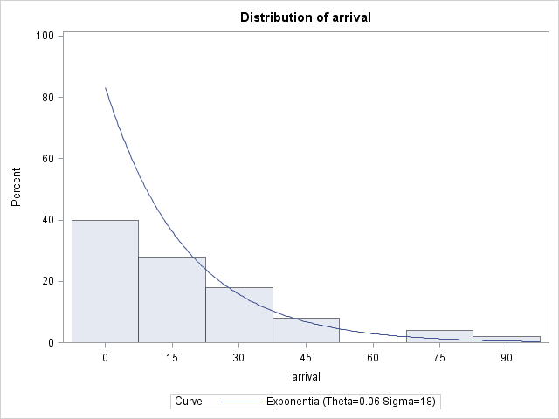(b)

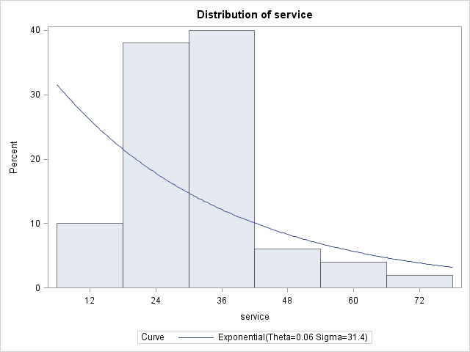(c)

(d) The distribution of arrival looks exponential while the distribution of service looks not that exponential bu slightly normal. My conclusion is that it is because the time of arrival depends on how people flow but the time of service depends on the server.

3.(a)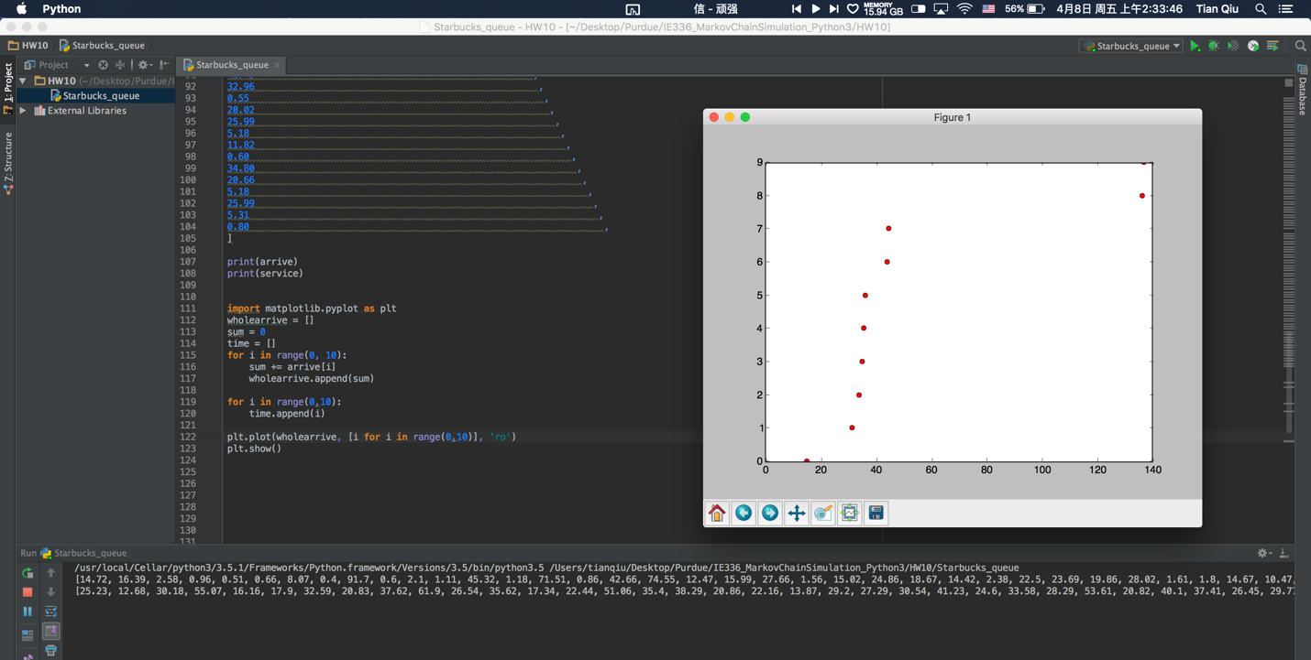

(b) The same as 2.

(c) Poisson Random: 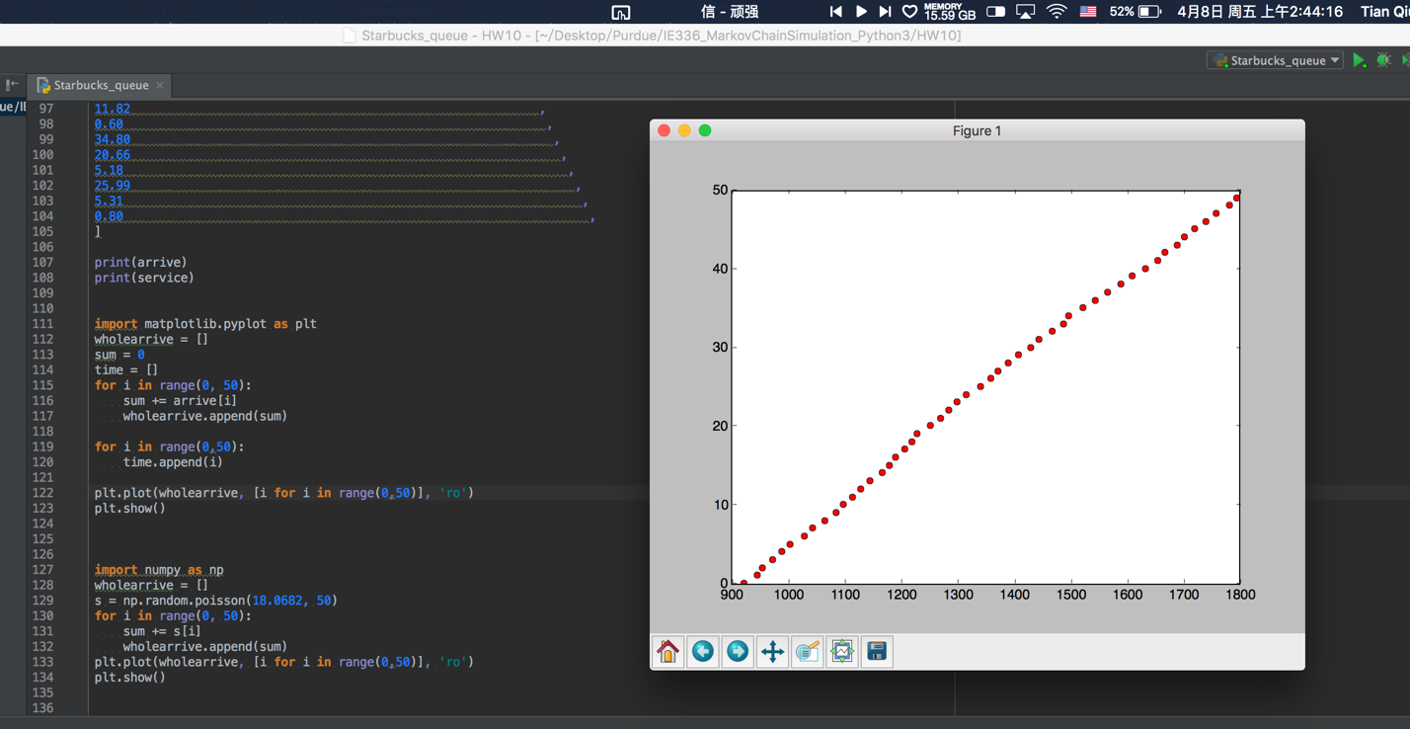

Real data:

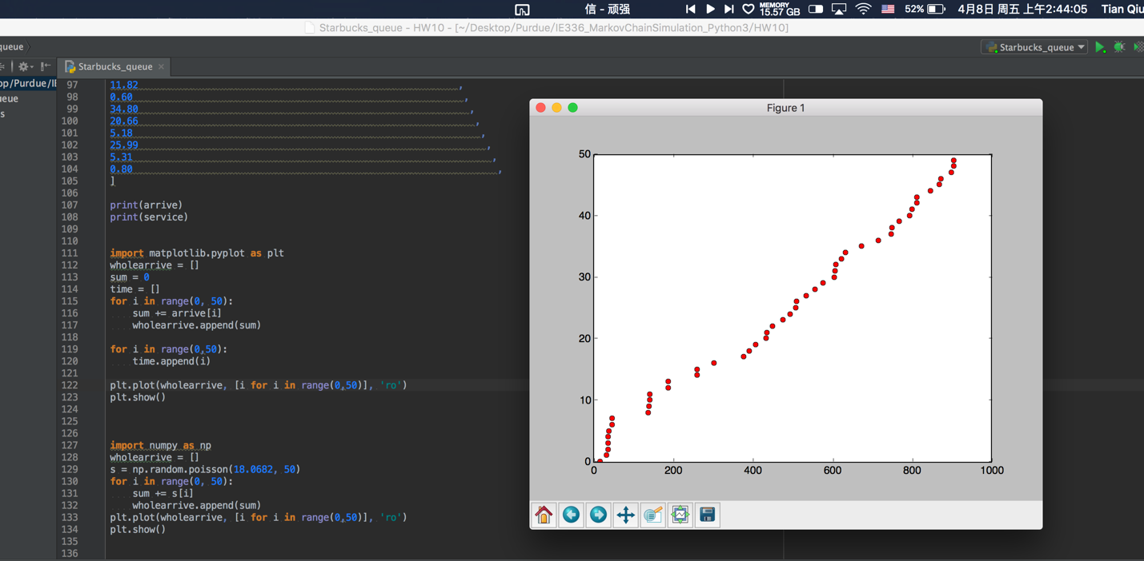

(d) They are not quite similar. It is not enough to say poisson is a good model to simulate the queue theory. I would say we need more test case like 500 people to test this model.